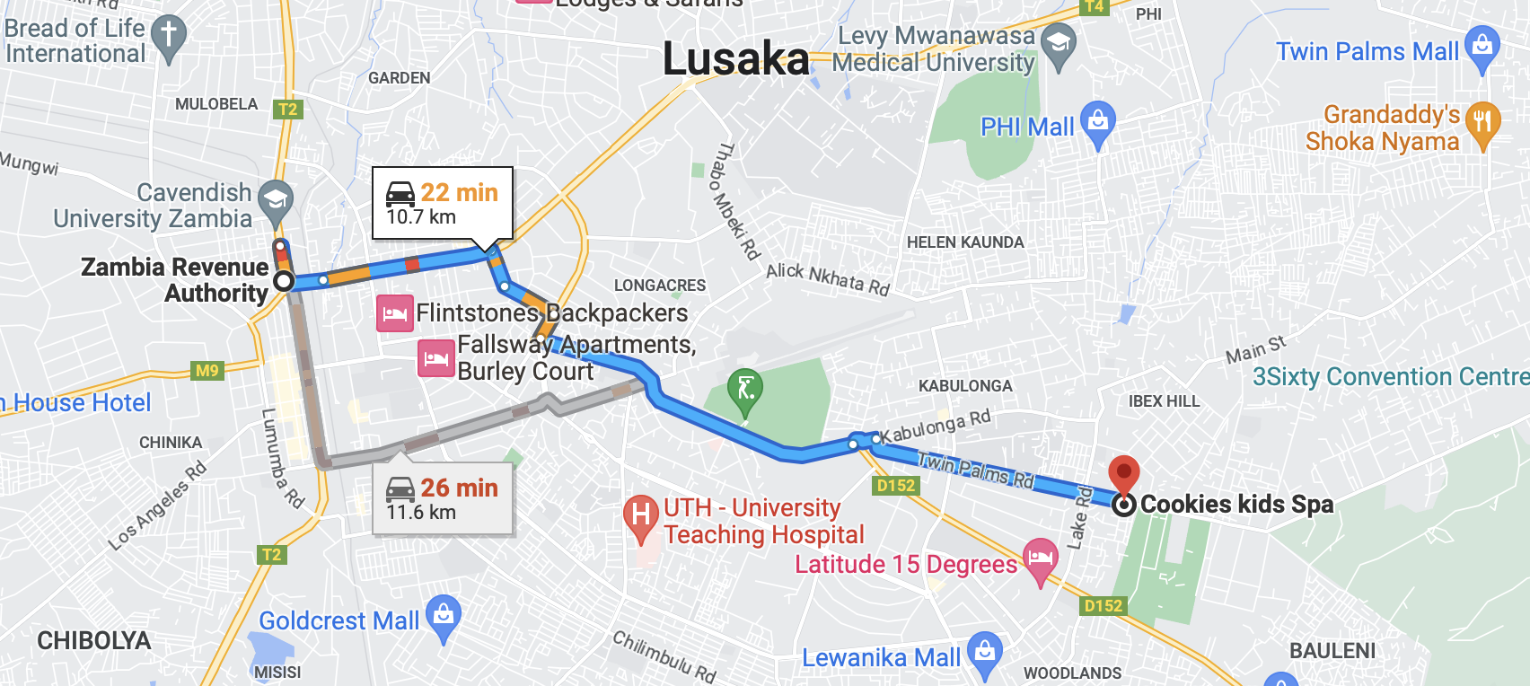

Plot, 64/100 Twin Palms Rd, Lusaka